Module B.1: Level 3 Flowchart Conventions

1. Flow Chart Symbols:

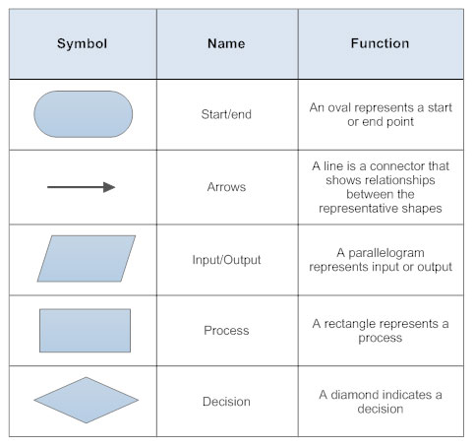



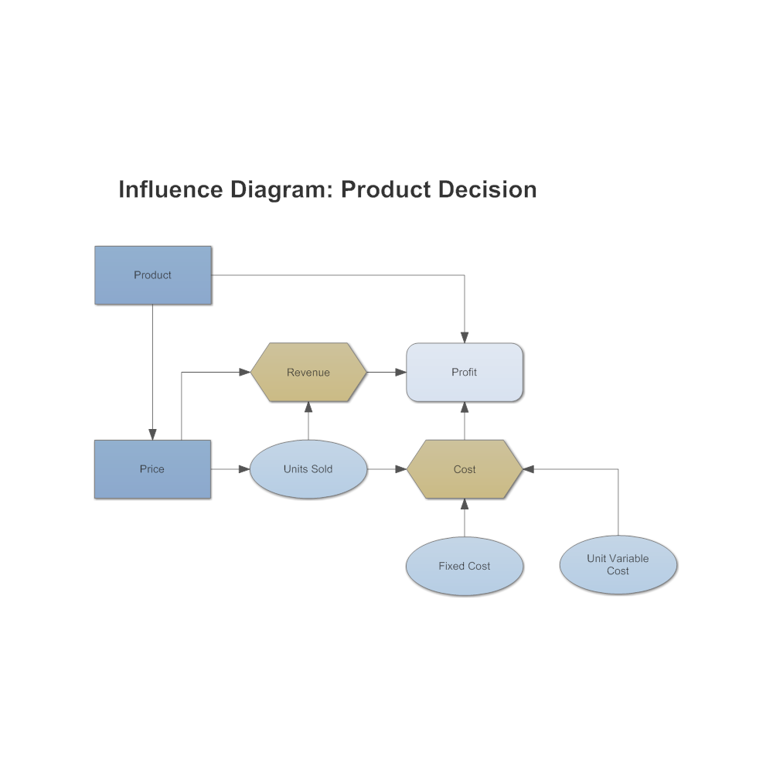

This flowchart is explaining the process of selling products. It uses the square symbol to show a process, arrows to show the transition, and ovals to show the start and the end.

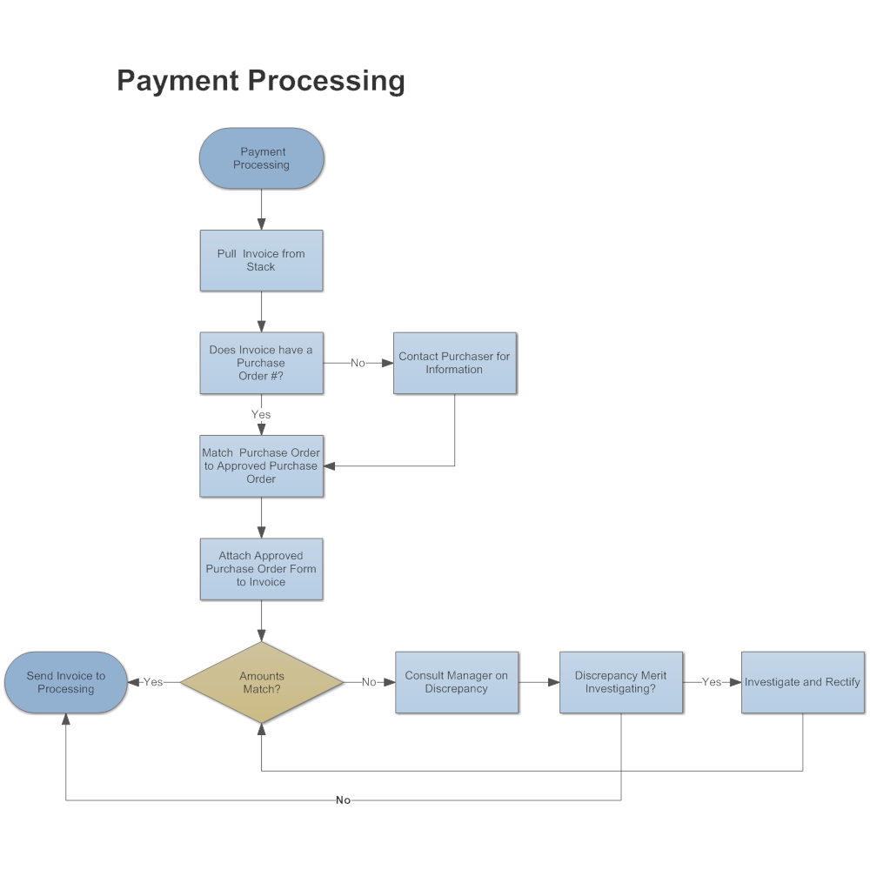

The second flowchart shows the process of payment for an online purchase. This flowchart uses an oval symbol to indicate the beginning and end of the flowchart, uses a diamond symbol to represent a decision, and uses rectangle symbols to represent a process.